YOUTH ADVISORY COUNCIL (YAC) MEETING
March 13, 2024
YAC Meeting Agenda:
The meeting agenda included a presentation from Lisa Porras, Planning Manager, and the consultant team, WRT, and focused on the streetscape design and programming concepts for the Downtown Specific Plan Area; followed by a discussion, group activity, and a visual reference survey to understand Youth Advisory Committee’s expectations from the Downtown Specific Plan. This meeting provided the city staff and the consultant team with a list of programs and public space design elements to consider in the Downtown Specific Plan Area.

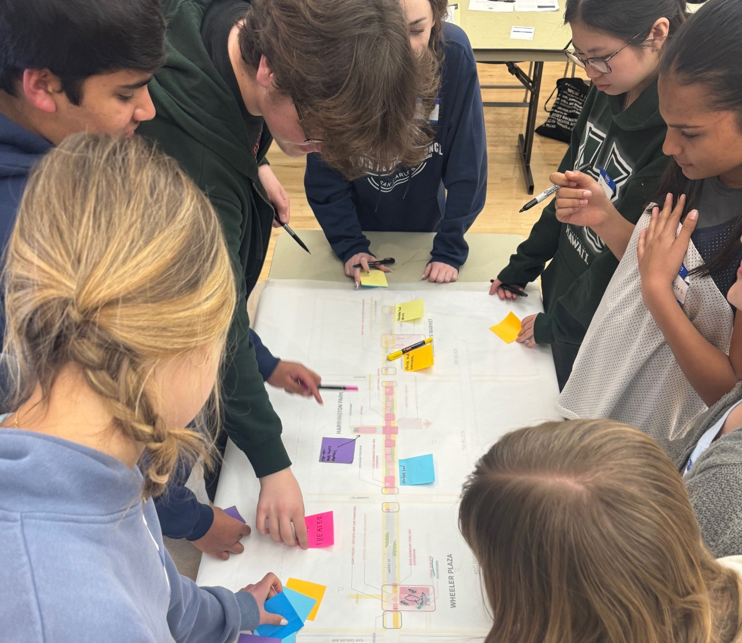
The feedback from the Youth Advisory Council is summarized below.
YAC Group Activity and Input

Program Elements: The YAC recommended the following program elements for the Laurel Street blocks: 600, 700, and 800, and for Wheeler Plaza and Harrington Park.
- Roller and ice-staking rinks
- Pop-up snack stalls that allow businesses to rotate weekly
- Food trucks
- Street festival area
- Mini golf as an entertainment option
- Bowling alley, arcade, or similar fun activity
- Designated informal eating area
- Permanent art display boxes for the community to display art as a rotating activity
- Movie theatre

Public Space Design Elements: to improve the quality of public space through design.
- Include shade-giving canopy trees near Wheeler Plaza
- The idea of “groves” is preferred
- Enhance Harrington Park and provide better visibility from the street to add a safety component
- Explore alleyway lighting as a design element
- Introduce benches along the street and in the plazas
- Introduce informal gathering areas
Infrastructure Elements:
Introduce drinking water fountains and water bottle filling stations
- Include the storm/rain gardens in the street design for a sustainable and resilient downtown
- Provide trash bins with segregated recycle and compost cans
- Introduce an EV charging facility integrated with parking
- Provide permanent public restrooms

Parking:
- Increase parking visibility with digital signage indicating available spaces
- Introduce parking meters/pick-up zones in the alley adjacent to Wheeler Plaza
- Create drop-off/pick-up or 10-minute parking zones on Laurel Street, near Starbucks
- Introduce a new name for Wheeler Plaza
- Explore the feasibility of a parking garage
- Overall, introduce time restrictions for parking along Laurel Street so that the customers as well as employees do not occupy the parking spots for a longer time
- Include ADA parking spaces

Downtown Business Strategy: The members suggested the following strategies to make the downtown businesses more diverse, affordable, and well spread out across the three blocks of Laurel Street (600, 700, and 800).
- Encourage establishments/stores selling office supplies/stationery
- Encourage addition of popular retail stores like Lululemon
- Promote affordable small businesses and diverse food options, for instance, invite specific businesses like Jamba Juice and Baskin Robbins to provide cheaper quick-eat options
- Consider incentivizing stores to set up businesses in the 800 block to have a more even spread of businesses in the three downtown blocks
- Suggest adding teenage-friendly clothing stores that are fun and engaging

Visual Preference Survey

The YAC members participated in the visual preference survey by placing a colored stickers on the programs they preferred or supported in the downtown area. The categories programs that were included in the survey were:

- Children and youth programs
- Food and beverage/ pop-up market
- Pedestrian-oriented programs
- Event day programs
- Infrastructure and amenities

The exercise concluded with the following understanding:

- The YAC members prefer play facilities, interactive paving patterns, and interactive sculpture as programs for children and youth. An outdoor climbing wall was not preferred as a program to introduce in the Specific Plan area.
- From the food and beverages standpoint, the YAC members prefer programs such as food trucks, micro-retail facilities, outdoor dining along wide sidewalks, and pop-up markets.
- Regarding the pedestrian-oriented programs, the YAC members prefer the programs including the groves with seating, multi-purpose plaza spaces, and the family seating area. The bike dismount zone was not a preferred programming concept for YAC.
- For the event day programs, the YAC members prefer an introduction to the performance area consisting of a stage, movie screen, and associated seating area. The members also prefer the seasonal ice staking rink and art display zones.
- From the infrastructure standpoint, the YAC members prefer drinking water fountains, restrooms, and green infrastructure elements.

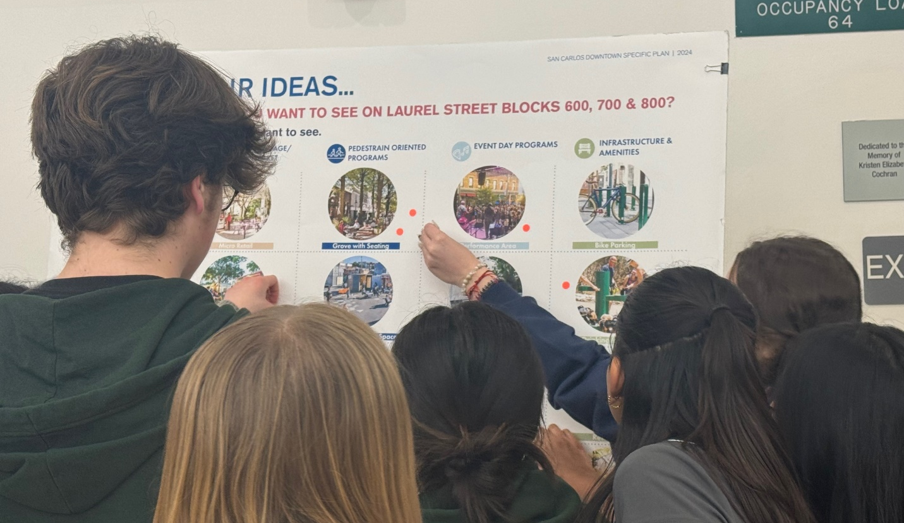

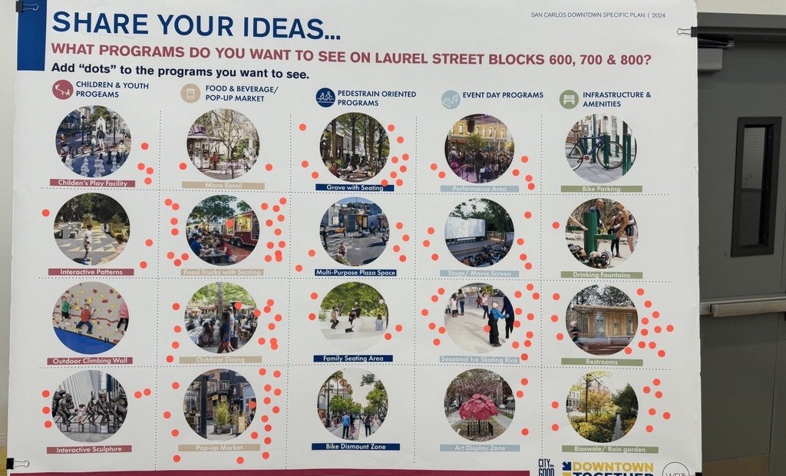
YAC Committee Members participating in the group activity.

